TECR Net for Validation Based Next Year Recorded Regulatory Non Compliance Risk in Offshore Platforms

Abstract

Risk-based offshore supervision requires models that respect temporal order, severe class imbalance, and the distinction between recorded enforcement outcomes and latent non-compliance. This study develops TECR-Net, a temporal cross-modal neural network that estimates whether a U.S. offshore platform will have a recorded incident of non-compliance in the next calendar year. Seven public Bureau of Safety and Environmental Enforcement data collections were integrated into a 141,730-row platform-year panel. Exact consecutive three-year histories were constructed, and the internal validation cohort comprised 1,884 sequences from 982 platforms during 2020–2021, including 67 positive outcomes (3.56%). TECR-Net combines gated dynamic inputs, a bidirectional gated recurrent unit, temporal attention, static and categorical encoders, cross-modal attention, residual fusion, and class-balanced focal loss. Across seven random seeds, validation PR-AUC was 0.0740 ± 0.0077 and validation ROC-AUC was 0.6312 ± 0.0112. The seven-seed probability ensemble obtained validation PR-AUC 0.0752, 2.11 times prevalence, ROC-AUC 0.6386, F1 0.1215, and Brier score 0.0341. At the validation-selected threshold, the model identified 13 of 67 positives and produced 134 false positives.

Keywords: offshore platforms; recorded incident of non-compliance; internal validation; temporal modelling; cross-modal learning; rare-event prediction; regulatory supervision

Introduction
The oil and gas industry relies on extensive technical, safety, environmental, and operational standards to control risks across complex infrastructure. Conventional supervision based on periodic inspections and static checklists is often insufficient for processing heterogeneous standards and large operational datasets. Liu et al. [1] proposed an LLM-based assessment framework that combines semantic indicator extraction, integrated weighting, and cloud-model evaluation for international pipeline standards. Hui et al. [2] further demonstrated how a knowledge graph constructed from more than 3,000 pipeline standards can improve semantic organization, intelligent retrieval, and practical access to technical requirements. Although these studies advance the intelligent management of standards, they focus mainly on standard formulation and knowledge retrieval rather than evaluating whether operating facilities consistently satisfy those requirements.
Effective standardization evaluation also depends on reliable data and defensible performance indicators. Xia et al. [3] developed multidimensional control rules for assessing the normative compliance, integrity, consistency, accuracy, and timeliness of oil-and-gas surface-engineering data. Their approach combined the Analytic Hierarchy Process with entropy weighting to produce quantitative data-quality assessments. Khordoustan et al. [4] integrated fuzzy Analytic Network Process weighting with machine-learning feature importance to evaluate contractor health, safety, environmental, and quality performance. This hybrid approach showed that expert knowledge and empirical evidence can jointly support transparent and interpretable evaluation. Nevertheless, an important gap remains in integrating facility characteristics, production activity, inspection history, safety incidents, and regulatory outcomes into a unified standardization-supervision model.
Risk-based asset integrity management provides a suitable foundation for addressing this gap. Wahono et al. [5] showed that integrity assessment is progressing from qualitative and deterministic methods toward dynamic, probabilistic, and machine-learning approaches using real operational data. However, existing studies rarely combine multidimensional indicators, longitudinal regulatory records, predictive modelling, and explainable AI at the facility level. Therefore, this study proposes a data-driven standardization supervision and evaluation framework for offshore oil and gas platforms. Using structural, production, inspection, incident, and non-compliance data, the framework will evaluate present performance, predict future regulatory non-compliance, identify abnormal risk patterns, and explain the principal factors influencing each prediction. The resulting system is intended to support transparent, proactive, and risk-based supervisory decision-making.

Literature Survey
Zhang et al. [6] reviewed the development of risk-assessment methods for oil and gas operations, covering conventional qualitative, quantitative, probabilistic, and intelligent techniques. They emphasized that traditional approaches depend heavily on expert judgment and often struggle to represent dynamic interactions among operational, environmental, and equipment-related risks. Wahono et al. [7] addressed these limitations through an intuitionistic fuzzy deep neural network for pipeline risk assessment. Their approach combines fuzzy representation of uncertain information with the nonlinear learning capability of deep neural networks. Together, these studies demonstrate the transition from static, expert-oriented risk evaluation toward intelligent models capable of managing uncertainty and complex relationships. However, their focus remains primarily on risk estimation rather than comprehensive standardization supervision and regulatory non-compliance prediction.
Zhou et al. [8] proposed a data-driven framework combining principal component analysis and hierarchical clustering for adaptive assessment of gas pipeline networks. Principal component analysis reduced indicator redundancy, while hierarchical clustering supported the identification of risk groups without relying entirely on predetermined categories. Ye et al. [9] employed text mining and the Apriori algorithm to classify oil and natural gas pipeline risks from historical risk records. Their method extracted recurring associations among risk factors and supported a data-driven risk-classification structure. Both studies demonstrate the value of discovering risk patterns directly from heterogeneous records. Nevertheless, clustering and association-rule methods mainly describe existing structures and relationships; they provide limited capability for predicting future non-compliance events or explaining facility-level regulatory performance within a longitudinal supervision framework.
AlAbdouli and Al-Shihabi [10] examined the performance impacts, challenges, and evaluation approaches associated with artificial intelligence adoption in the oil and gas industry. They highlighted AI’s potential to improve prediction, operational efficiency, maintenance, and decision-making while identifying concerns related to data quality, integration, interpretability, and organizational readiness. Savari et al. [11] systematically reviewed machine-learning advances in pipeline reliability-based design, integrity assessment, inspection, and maintenance. Their review showed that machine learning increasingly supports condition assessment, failure prediction, inspection planning, and maintenance optimization. These studies establish the wider relevance of AI for industrial performance and pipeline integrity. However, they also indicate that reliable implementation requires transparent models, well-governed data, and evaluation frameworks aligned with operational and regulatory objectives.
Bastek et al. [12] reviewed future directions for data-driven pipeline integrity management, with particular attention to risk assessment, in-line inspection, and machine-learning applications. They emphasized the need to integrate inspection information, physical degradation indicators, and operational data to support proactive integrity decisions. Jones et al. [13] examined artificial-intelligence applications for offshore oil and gas pipeline asset integrity management. Their study discussed how intelligent methods can enhance corrosion monitoring, defect assessment, predictive maintenance, and failure prevention throughout the asset lifecycle. Collectively, these studies support the transition from reactive maintenance toward predictive and risk-based integrity management. Nevertheless, existing research generally prioritizes physical asset condition and failure probability, while regulatory compliance, inspection history, and multidimensional standardization performance remain comparatively underexplored.
Al-Ammari et al. [14] reviewed and demonstrated digital-twin applications for gas-pipeline leak detection and fault diagnosis. Their work showed how virtual representations, sensor information, and analytical models can support continuous monitoring and timely identification of abnormal pipeline conditions. Cai and Wang [15] subsequently proposed a digital-twin-driven leakage-detection method for natural gas pipelines, further illustrating the potential of synchronized physical and virtual systems for real-time supervision. Both studies advance dynamic pipeline monitoring by linking operational data with intelligent diagnostic models. However, digital-twin systems often require dense sensor networks, detailed physical models, and continuous data streams. Such requirements limit their direct applicability to regulatory datasets, where observations are commonly periodic, heterogeneous, and recorded at facility or operator level rather than as continuous sensor measurements.
Ali et al. [16] reviewed artificial-intelligence and machine-learning methods for predicting and optimizing production in oil and gas surface networks. Their study demonstrated the ability of data-driven models to capture nonlinear relationships among operational variables and support production planning and network optimization. Chen et al. [17] extended production monitoring through a progression from clustering to federated learning for unconventional natural gas wells. Their collaborative approach enables multiple data sources or operational units to contribute to model development while reducing centralized data-sharing requirements. These studies demonstrate the importance of scalable learning from distributed and heterogeneous industrial data. However, production optimization alone does not represent standardization performance. A comprehensive supervision framework must connect operational behaviour with facility characteristics, inspection activities, incidents, and regulatory outcomes.
Lopes et al. [18] developed an open-world learning approach for detecting and classifying anomalies in oil-well production. Unlike closed-set classifiers, open-world learning can identify observations that do not belong to previously known event classes, making it relevant for evolving industrial environments. Aranha et al. [19] applied a Transformer-based method to anomaly detection in intelligent well completions, using the architecture’s ability to learn complex temporal dependencies within multivariate operational sequences. Both studies demonstrate that advanced learning methods can identify abnormal behaviour that conventional fixed-class models may overlook. Nevertheless, operational anomalies do not automatically represent regulatory non-compliance or inadequate standardization. Their practical use in supervision therefore requires integration with inspection records, compliance histories, interpretable risk indicators, and decision rules that translate anomalies into actionable regulatory or managerial priorities.
Verma et al. [20] proposed DeepPipeNet for deep-learning-based anomaly detection in oil and gas pipeline monitoring, illustrating the growing role of specialized neural architectures in identifying complex pipeline abnormalities. Its emphasis on automated monitoring complements the open-world anomaly framework of Lopes et al. [18], which addresses previously unseen operational conditions. While DeepPipeNet strengthens pattern-recognition capability, both approaches remain centred on detecting abnormal physical behaviour rather than evaluating broader compliance performance. This distinction is important because standardization supervision must account for operational exposure, structural characteristics, inspection frequency, previous violations, enforcement actions, and safety incidents. Consequently, anomaly-detection outputs should be treated as one component of a larger explainable evaluation framework rather than as a complete measure of facility standardization or regulatory risk.
Table 2. Comparative summary of AI-based oil and gas monitoring, integrity, and risk-assessment studies
Ref. | Author(s) | Dataset used | Model/method used | Research gap
[21] | Almahakeri et al. | Ultrasound-guided-wave measurements collected through pipeline-mounted transducers | Deep Neural Network-based structural health monitoring; compared with five ML models | Predicts crack location, width, and depth but does not evaluate regulatory compliance, inspection history, or facility-level risk.
[22] | Wang et al. | Historical operational and fault data from Shengli Oilfield production wells | ML-CSNN, expert rules, SVM, GBDT, and XGBoost | Strong predictive-maintenance performance, but validation is limited to one oilfield and equipment-fault context.
[23] | Sani et al. | Public corrosion dataset: 10,293 observations and eight operational features | Gradient Boosting, XGBoost, Random Forest, KNN, SVR, AdaBoost, and regression models | Uses a public tabular dataset and random split; limited evidence of temporal, geographic, and operator-level generalization.
[24] | Ansari et al. | TWI industrial dataset containing over 35,000 condition-monitoring locations | Direct regression and composite classification–regression models | Performs poorly for high corrosion rates and is affected by skewness, duplicate records, and limited severe cases.
[25] | Wu et al. | 402 burst-test and finite-element samples collected from published studies | Physics-informed deep forest optimized through Double Deep Q-Network domain generalization | Dataset mainly represents simplified single rectangular defects; operational and regulatory factors are excluded.
[26] | Wang and Lu | Datasets collected from 30 published residual-strength studies | Review of regression, Random Forest, SVM, neural networks, Gaussian Process Regression, and ensemble methods | Identifies small, heterogeneous datasets and inconsistent validation; does not propose a unified operational framework.
[27] | Chen et al. | Experimental and operating data for liquid holdup in hilly oil–gas pipelines | Comparative ML prediction with SHAP interpretation | Focuses on liquid holdup under specific terrain and flow conditions rather than broader integrity or compliance outcomes.
[28] | Lv et al. | High-pressure hydrate flow-loop experimental data from an oil–water system | XGBoost classification with SHAP explanations | High controlled-experiment accuracy, but field-scale and cross-pipeline validation remain limited.
[29] | Yang et al. | Geological, environmental, and hazard data from the Lishui–Wenzhou gas-pipeline corridor | Information Value Method, neural-network weighting, and data-driven susceptibility assessment | Case-study-specific geographic model; limited transferability to other regions and non-geological compliance risks.
[30] | Chen et al. | Field measurements combined with hydraulic-simulation benchmarks | Eight lightweight ML models optimized for edge deployment | Addresses short-term overpressure warning but not long-term integrity, inspection performance, or regulatory supervision.
[31] | Khalilzadeh et al. | Literature evidence, organizational information, and expert judgments from an oil and gas project | Fuzzy Delphi, probability–impact matrix, FBWM, and Grey CoCoSo | Relies strongly on expert assessment and lacks longitudinal operational validation or predictive regulatory outcomes.
[32] | Zhang et al. | Published studies and selected oilfield application cases; no single experimental dataset | Systematic review of big-data monitoring, ML, deep learning, anomaly detection, and parameter optimization | Provides broad conceptual coverage but lacks a reproducible dataset, unified model, and comparative experimental validation.
The reviewed studies demonstrate substantial progress in pipeline crack monitoring, equipment maintenance, corrosion prediction, residual-strength estimation, flow assurance, geological-hazard assessment, and real-time failure warning. However, most use specialized experimental, simulation, or single-organization datasets and address one physical failure mechanism. Several studies also rely on random data partitions, small samples, expert judgments, or geographically restricted case studies, limiting temporal and cross-facility generalization. Few integrate production exposure, infrastructure characteristics, inspection activity, incident history, enforcement actions, and regulatory non-compliance within one longitudinal framework. These limitations motivate the proposed study, which uses multi-source BSEE platform-year data to predict future non-compliance and provide explainable, facility-level evidence for risk-based standardization supervision.

3. Proposed Methodology
3.1 Prediction Target
The proposed Temporal Enhanced Compliance Risk Network (TECR-Net) is designed to predict offshore platform-level regulatory noncompliance risk using historical operational, structural, and supervisory information. The prediction task is formulated as binary classification, where the objective is to estimate whether a platform will record at least one Incident of Non-Compliance (INC) during the calendar year immediately following the observation period. For platform $i$and feature year $t,$the binary outcome is defined as:

$yᵢ,ₜ₊₁ = 1(INC_countᵢ,ₜ₊₁ > 0)$ (1)
where $1\left(⋅\right)$denotes the indicator function. A positive label represents at least one recorded INC in year $t+1$, while a negative label indicates that no INC was recorded during that year. This formulation enables the model to estimate next-year regulatory risk rather than contemporaneous compliance status.
To capture the temporal evolution of platform conditions, each observation is represented by an exact three-year sequence of historical features:

$Xᵢ,ₜ = [xᵢ,ₜ₋₂, xᵢ,ₜ₋₁, xᵢ,ₜ] ∈ R³ˣ²⁶$ (2)
where each annual feature vector contains 26 dynamic variables under the enhanced-supervision configuration. Only consecutive calendar-year observations are accepted, ensuring that the temporal encoder receives consistently spaced histories. Records with missing intermediate years are excluded rather than being treated as adjacent observations. This design preserves temporal continuity and ensures that the prediction horizon remains fixed at one calendar year.

3.2 Data Integration

Seven publicly available BSEE data collections were integrated to construct a longitudinal platform-level dataset, including platform structures, platform-level production, production summaries, INC and inspection records, accident investigations, company records, and lease ownership information. These sources provide complementary information about infrastructure characteristics, production exposure, operational activity, organizational context, historical incidents, and regulatory supervision. The resulting integrated panel contained 141,730 platform-year observations covering 6,158 offshore platforms and 49 variables from 1947 to 2025. To improve temporal consistency and feature availability, model construction was restricted to recent years, producing 12,280 eligible three-year sequences.

The model input variables were organized into dynamic, static numerical, and categorical groups according to their temporal characteristics. The dynamic representation comprises 20 operational variables and six historical compliance-related variables, resulting in 26 features at each time step. Three static numerical variables represent comparatively stable platform characteristics, while eight categorical variables describe geographic, structural, and operating-context attributes. Metadata identifiers were retained exclusively for dataset integration, grouping, and integrity verification. Future outcomes, target-derived fields, and removal timing were excluded from the approved predictor list.
Table 2 specifies what enters each TECR-Net branch and which fields remain metadata or prohibited variables.

Table 2. Prespecified model input groups and their timing
Group | Count | Content | Use
Dynamic base | 20 | Production, wells, activity, change, age, operator activity, lagged accident indicators | Each of t−2, t−1, t
Current compliance | 6 | Year-specific INC, warning, shut-in, and inspection-derived history | Enhanced supervision only
Static numerical | 3 | Water depth and stable structural quantities | Once per sequence
Categorical | 8 | Area, structure and operating-context categories | Training-derived vocabulary
Metadata | — | Platform, lease, operator, complex, and grouping identifiers | Not predictive inputs
Prohibited | — | Future targets, next_year fields, removal timing | Excluded before fitting

Table 3 summarizes the feature organization adopted in TECR-Net. The temporal encoder receives 26 dynamic variables across three consecutive annual observations, while the static and categorical branches encode complementary contextual information. Historical compliance indicators represent previously recorded regulatory activity rather than future outcomes. Nevertheless, the historical availability of individual features, particularly static snapshots and organizational attributes, requires source-date verification. Lease-level accident indicators are also treated as contextual proxies because the same accident information may be associated with multiple platforms.

3.3 Temporal Design and Validation Cohort

A chronological partitioning strategy was adopted to evaluate prediction performance under changing operational and regulatory conditions. The model-fitting cohort covers feature years 2014–2019, the internal validation cohort includes 2020–2021, and a later cohort covering 2022–2024 was reserved for subsequent independent evaluation. Each input sequence consists of three consecutive historical observations, with the binary outcome defined for the immediately following calendar year. This design prevents random mixing of earlier and later feature-year observations, although the availability of target records at the model-fitting date must also be verified.
Table 3. Temporal protocol and cohort sizes

Role | Feature years | Sequences | Platforms | Positive labels | Label rate
Model fitting | 2014–2019 | 8,200 | 1,607 | 538 | 6.56%
Internal validation | 2020–2021 | 1,884 | 982 | 67 | 3.56%
Reserved later cohort | 2022–2024 | 2,196 | 876 | 94 | 4.28%

Table 4 demonstrates a reduction in positive-label prevalence from 6.56% in the fitting cohort to 3.56% during internal validation. This variation indicates a change in the observed outcome distribution, although it does not independently establish concept drift or changes in the underlying regulatory risk mechanism. The later cohort is documented to preserve the temporal evaluation protocol; its model performance is not included in the present validation-only analysis. Because multiple sequences can originate from the same platform, the distinction between platform-level and sequence-level evaluation is maintained throughout performance reporting.

3.4 Leakage Controls and Preprocessing
To minimize temporal information leakage, preprocessing parameters were estimated exclusively from the model-fitting cohort and applied unchanged to validation observations. Numerical preprocessing consisted of quantile clipping, missing-value imputation, and robust scaling, while categorical vocabularies were derived from the fitting data. The preprocessing procedure was designed to prevent distributional information from the validation period from influencing transformation parameters.
Numerical feature values were first constrained using the first and ninety-ninth percentiles of their fitting-period distributions:

$x̃ⱼ = min(max(xⱼ, Qⱼ,0.01), Qⱼ,0.99)$ (3)
where $Q_{j,0.01}$ and $Q_{j,0.99}$ denote the fitting-period quantiles of feature j. Missing numerical observations were subsequently replaced using the corresponding fitting-period median:
$${\overset{ˆ}{x}}_{j}=\left\{\begin{matrix}{\overset{˜}{x}}_{j}, & \text{if observed}, \\ {median}_{fit}\left(x_{j}\right), & \text{otherwise}.\end{matrix}\right.$$ (4)
Finally, robust scaling was applied to reduce the influence of extreme feature distributions:
$$z_{j}=\frac{{\overset{ˆ}{x}}_{j}-{median}_{fit}\left(x_{j}\right)}{{IQR}_{fit}\left(x_{j}\right)}$$ (5)
where ${IQR}_{fit}\left(x_{j}\right)$represents the interquartile range obtained from fitting observations. A nonzero denominator safeguard is required for features with zero interquartile range. All transformations were applied consistently to the three historical observations, with no oversampling performed before temporal partitioning.
Table 5. Data leakage and temporal-integrity assessment
Check | Status | Interpretation
Unique platform-year records | Pass | No duplicates
Target fields in approved inputs | Pass | None
Future or removal fields in inputs | Pass | None
Identifiers in feature whitelist | Pass | None
Consecutive three-year windows | Pass | No spacing violations
Immediate next-year label alignment | Pass | No mismatches

Table 5 summarizes the existing leakage and integrity checks. The reported audits support the exclusion of explicit target-derived variables and confirm consecutive input sequences with correctly associated next-year labels. Nevertheless, these checks do not establish that every predictor was historically available at the corresponding prediction origin. In particular, static snapshots and organization-related variables require verification of their effective dates.Consequently, the dataset is treated as having passed the documented structural checks rather than being fully verified against every possible source of temporal leakage.

3.5 TECR-Net Architecture
The TECR-Net architecture integrates gated temporal representation learning with static numerical encoding, categorical embeddings, and cross-modal attention. The network is designed to combine historical operational information and relatively stable platform characteristics through complementary representation branches. The architecture contains four principal stages: dynamic feature gating and recurrent encoding, temporal attention aggregation, static and categorical representation learning, and multimodal fusion followed by binary risk estimation

3.5.1 Feature Gate and Bidirectional Temporal Encoder
The dynamic input sequence is initially processed using a sigmoid feature-gating mechanism that learns a multiplicative weight for each variable at each historical time step. This mechanism allows the network to adjust the contribution of individual operational and supervisory indicators before temporal encoding. Given the dynamic feature vector \(x_{i,k}\), the gating operation is defined as:
$gᵢ,ₖ = σ(Wg xᵢ,ₖ + bg), x'ᵢ,ₖ = gᵢ,ₖ ⊙ xᵢ,ₖ$ (6)
where $W_{g}$and $b_{g}$are trainable parameters, $σ$denotes the sigmoid function, and $⊙$represents element-wise multiplication.
The gated sequences are subsequently processed using a one-layer bidirectional Gated Recurrent Unit (GRU), consisting of 80 hidden units in each direction. The forward and backward recurrent states are calculated as:

$h⃗ᵢ,ₖ = GRU⃗(x'ᵢ,ₖ, h⃗ᵢ,ₖ₋₁)$ (7)
$h⃖ᵢ,ₖ = GRU⃖(x'ᵢ,ₖ, h⃖ᵢ,ₖ₊₁)$ (8)
The directional representations are concatenated to construct the temporal hidden state:
$hᵢ,ₖ = [h⃗ᵢ,ₖ ∥ h⃖ᵢ,ₖ] ∈ R¹⁶⁰$ (9)
The bidirectional recurrent encoder processes relationships among the three historical observations while remaining restricted to information available within the observed sequence. The resulting 160-dimensional hidden representations provide the inputs for the temporal attention mechanism.

3.5.2 Temporal Attention
A temporal attention mechanism is introduced to model differences in the relative contribution of historical observations. Instead of relying on the final recurrent state alone, attention aggregates information from all three encoded years. The relevance score associated with time step $k$ is calculated using additive attention:
$eᵢ,ₖ = vₐᵀ tanh(Wₐhᵢ,ₖ + bₐ)$ (10)
The normalized attention weights are obtained as:
$$α_{i,k}=\frac{\exp\left(e_{i,k}\right)}{\sum_{r=1}^{3}{\exp\left(e_{i,r}\right)}}$$ (11)
The temporal context vector is subsequently constructed through weighted aggregation:
$$c_{i}=\sum_{k=1}^{3}{α_{i,k}}h_{i,k}$$ (12)
The resulting representation is projected into an 80-dimensional shared latent space using a linear transformation, GELU activation, and layer normalization:
$zᵀᵢ = LN(GELU(Wₜcᵢ + bₜ))$ (13)
This approach enables adaptive aggregation of historical information according to learned predictive associations. However, the attention coefficients are treated as internal model weights rather than causal explanations of regulatory risk.

3.5.3 Static and Categorical Encoders
The static numerical branch processes three platform-level attributes using a two-layer multilayer perceptron (MLP). The transformation maps the original numerical inputs into an 80-dimensional representation:
$zˢᵢ = LN(Ws,2 Dropout(GELU(Ws,1sᵢ + bs,1)) + bs,2)$ (14)
where $s_{i}∈R^{3}$represents the static numerical input vector. This encoder captures nonlinear associations among stable structural attributes and provides a representation compatible with the temporal branch.
Categorical information is represented using eight independent trainable embedding layers. Each categorical variable is transformed into a low-dimensional dense vector, with embedding sizes ranging from 3 to 16 dimensions. The embeddings are concatenated and projected into the same 80-dimensional space:

$zᶜᵢ = LN(Dropout(GELU(Wc [E₁(cᵢ1) ∥ … ∥ E₈(cᵢ8)] + bc)))$ (15)
The separate static and categorical branches allow the network to represent heterogeneous data types without directly introducing these attributes into the recurrent sequence. These representations complement the temporal features during subsequent multimodal integration.

3.5.4 Cross-Modal Attention and Residual Fusion
The encoded temporal, static, and categorical representations are integrated through an eight-head multi-head attention mechanism. Each modality is represented as an 80-dimensional token, while a learned query vector attends to the three modality representations. This mechanism allows the network to construct an aggregated representation from heterogeneous information sources.
The cross-modal attention output is calculated as:
$aᵢ = MHA(q, [zᵀᵢ,zˢᵢ,zᶜᵢ], [zᵀᵢ,zˢᵢ,zᶜᵢ])$ (16)
where $q$is the learned query and the modality representations provide the keys and values. The attention output is combined with the arithmetic mean of the three original modality tokens to retain a direct feature pathway:
$uᵢ = [aᵢ ∥ (zᵀᵢ + zˢᵢ + zᶜᵢ)/3]$ (17)
The fused representation is then processed by a nonlinear prediction head to estimate next-year recorded INC probability:
$pᵢ = σ(W₂ Dropout(GELU(W₁uᵢ + b₁)) + b₂)$ (18)
The final output $p_{i}∈\left[0,1\right]$ represents the uncalibrated probability estimate generated by TECR-Net. The residual concatenation retains information from the original modality tokens alongside the attention-derived representation. Although the architecture provides a structured mechanism for multimodal integration, the individual contribution of each component must be established through controlled ablation experiments rather than assumed from the architectural design.

3.6 Optimization and Validation Procedure
The network was optimized using class-balanced focal loss to address the severe imbalance between positive and negative INC outcomes. Focal loss reduces the relative contribution of correctly classified examples and increases the influence of observations that remain difficult to classify. The binary focal-loss objective is expressed as:
$L = -αy(1-p)ᵞlog(p) - (1-α)(1-y)pᵞlog(1-p)$ (19)
where $y$denotes the observed binary outcome, $p$represents the predicted positive-class probability, $α$is the class-weighting coefficient, and $γ$controls the focal emphasis. The focal exponent was fixed at 1.7523 in the reported configuration. The numerical class-weighting coefficient and its selection procedure should be documented from the original training implementation to ensure exact reproducibility.
Seven independent training runs were conducted using the predefined random seeds 11, 22, 33, 44, 55, 66, and 77. The model architecture and principal optimization settings were held constant across runs, allowing prediction variability associated with initialization and stochastic training to be examined. Training was limited to 100 epochs, with early stopping patience of 15 epochs. Seed-level performance was summarized using mean and standard deviation, while ensemble performance was evaluated separately.
In the reported experiment, each seed-specific network was calibrated using a logistic Platt transformation fitted on validation predictions. The ensemble score was subsequently formed by averaging the seven calibrated probabilities:

$${\overline{p}}_{i}=\frac{1}{7}\sum_{s=1}^{7}{σ}\left(a_{s}\operatorname{logit}\left(p_{i,s}\right)+b_{s}\right) (20)$$
where $p_{i,s}$denotes the uncalibrated prediction from seed $s,$and $a_{s}$and $b_{s}$represent the corresponding fitted calibration parameters. This equation describes the implemented internal-validation ensemble rather than an independently calibrated forecasting system.
Table 6. Locked TECR-Net architecture and optimization settings

Component | Configuration | Value
Dynamic encoder | Bidirectional GRU | 80 units per direction
Temporal projection | Linear, GELU, layer normalization | 160 to 80
Static encoder | Two-layer MLP | 3 to 80 to 80
Categorical encoder | Eight embeddings plus projection | Embedding dimensions 3–16
Cross-modal attention | Multi-head attention | 8 heads, 80-dimensional tokens
Dropout | Fixed | 0.2690
Learning rate | Fixed | 0.001617
Weight decay | Fixed | \(2.439\times10^{-5}\)
Focal exponent | Fixed | 1.7523
Batch size | Fixed | 256
Maximum epochs | Early stopping | 100, patience 15
Random seeds | Repeated training | 11, 22, 33, 44, 55, 66, 77

Table 6 summarizes the reported architecture and optimization settings. The seven-seed design permits descriptive evaluation of stochastic training variability under a fixed configuration. However, the use of the same internal validation cohort for calibration fitting, threshold selection, and performance reporting introduces potential optimism. Accordingly, the calibration and threshold-dependent results are interpreted as apparent internal-validation estimates rather than independently established forecasting performance. A separate calibration subset or out-of-fold calibration protocol, followed by evaluation on untouched chronological observations, is necessary to establish unbiased probability-quality estimates. Likewise, the exact early-stopping criterion, focal class weight, checkpoint-selection procedure, and calibration-fitting settings must be documented from the implementation before complete reproducibility can be claimed.

3.7 Evaluation Measures
The prediction framework was evaluated using complementary discrimination, classification, calibration, and operational ranking metrics. PR-AUC was designated as the primary metric because positive INC labels account for only 3.56% of the validation cohort. This metric summarizes the relationship between precision and recall across thresholds and is especially relevant to rare-event prioritization. ROC-AUC was additionally used to characterize global ranking discrimination, while F1-score, F2-score, precision, recall, specificity, balanced accuracy, and Matthews correlation coefficient were used to describe threshold-dependent classification behaviour.
Probability quality was examined using the Brier score and calibration diagnostics. Because the validation event rate is low, a numerically small Brier score does not necessarily indicate substantial improvement over a constant-probability predictor. Therefore, probability-quality interpretation requires an appropriate reference score and consideration of the calibration procedure. Operational usefulness was additionally assessed through Precision@K, Recall@K, and Lift@K at ranking budgets of 50, 100, and 200 observations.

Table 7. Evaluation measures and interpretation

Metric | Category | Purpose
PR-AUC | Threshold-free | Primary rare-event ranking performance
PR-AUC/prevalence | Threshold-free | Performance relative to the prevalence reference
ROC-AUC | Threshold-free | Overall discrimination between positive and negative observations
F1 and F2 | Threshold-dependent | Precision–recall trade-off, with greater recall emphasis in F2
Precision | Threshold-dependent | Positive predictive value
Recall | Threshold-dependent | Proportion of positive outcomes identified
Specificity | Threshold-dependent | Proportion of negative outcomes correctly rejected
Balanced accuracy | Threshold-dependent | Average sensitivity and specificity
MCC | Threshold-dependent | Classification association across all confusion-matrix outcomes
Brier score | Probability-based | Mean squared probability error
Calibration diagnostics | Probability-based | Agreement between estimated and observed event frequencies
Precision@K | Budget-based | Positive fraction among the top K ranked observations
Recall@K | Budget-based | Proportion of all positives captured within the top K
Lift@K | Budget-based | Precision@K relative to outcome prevalence

Table 7 distinguishes threshold-independent discrimination from classification performance at a selected operating threshold. Because the threshold was selected using validation labels, the corresponding F1, F2, precision, recall, and confusion-matrix outcomes are descriptive rather than independent estimates of operating performance. Similarly, probability calibration metrics calculated on the calibration-fitting cohort require verification before being interpreted as evidence of generalizable calibration. Precision@K and related ranking measures are defined over validation sequences; claims concerning unique-platform inspection prioritization require an explicit aggregation rule to avoid counting the same platform multiple times. Finally, comparative interpretation against conventional machine-learning baselines requires verification of identical validation identifiers, outcomes, prediction horizons, and compatible experimental conditions.

4. Validation Results

4.1 Seven-Seed Stability
Table 7 presents only validation results averaged across the seven prespecified seeds.
Table 7. TECR-Net validation performance across seven seeds
Metric | Mean | SD | Mean ± SD
Prevalence | 0.03556 | 0.00000 | 0.03556 ± 0.00000
PR-AUC | 0.07401 | 0.00775 | 0.07401 ± 0.00775
PR-AUC/prevalence | 2.08109 | 0.21780 | 2.08109 ± 0.21780
ROC-AUC | 0.63115 | 0.01119 | 0.63115 ± 0.01119
F1 | 0.12080 | 0.01976 | 0.12080 ± 0.01976
F2 | 0.15060 | 0.04063 | 0.15060 ± 0.04063
Precision | 0.10295 | 0.02972 | 0.10295 ± 0.02972
Recall | 0.22175 | 0.14861 | 0.22175 ± 0.14861
Balanced accuracy | 0.56197 | 0.02388 | 0.56197 ± 0.02388
Specificity | 0.90219 | 0.11113 | 0.90219 ± 0.11113
MCC | 0.08918 | 0.01780 | 0.08918 ± 0.01780
Brier score | 0.03407 | 0.00004 | 0.03407 ± 0.00004
Threshold | 0.04982 | 0.00516 | 0.04982 ± 0.00516
Precision@50 | 0.10857 | 0.02545 | 0.10857 ± 0.02545
Precision@100 | 0.08571 | 0.02225 | 0.08571 ± 0.02225
Precision@200 | 0.05857 | 0.01180 | 0.05857 ± 0.01180

Table 7 shows that validation PR-AUC averaged 0.07401 ± 0.00775, equivalent to 2.08 times prevalence, while ROC-AUC averaged 0.63115 ± 0.01119. Recall varied markedly across seeds, which explains the comparatively large variability in threshold-dependent measures. The more stable ranking measures support probability ensembling but do not demonstrate external generalization.
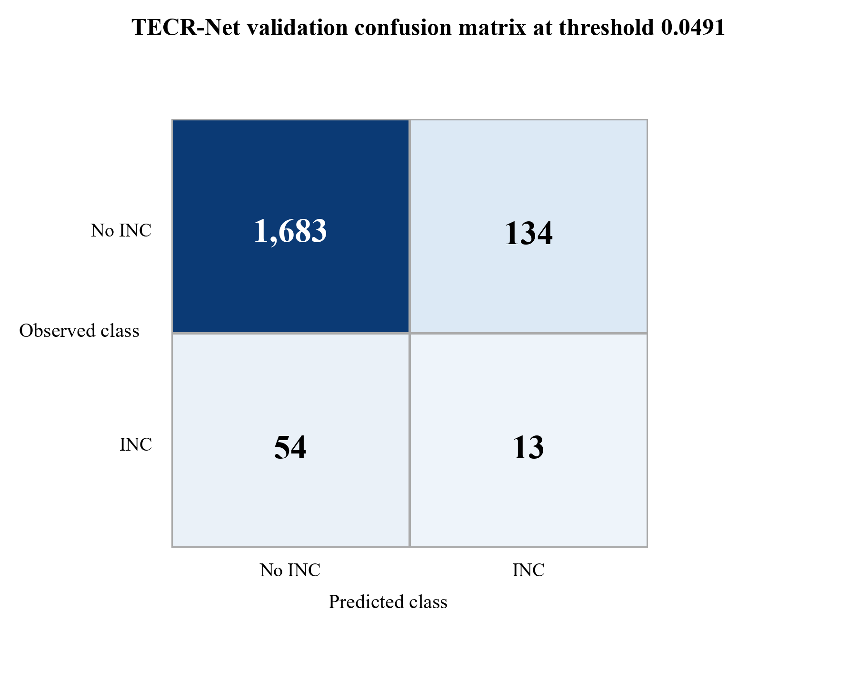
Figure 1. Validation-only confusion matrix for the seven-seed TECR-Net probability ensemble.
Figure 1 shows 1,683 true negatives, 134 false positives, 54 false negatives, and 13 true positives at threshold 0.0491. Specificity is high because most negative sequences remain below the threshold, but only 19.4% of the 67 positive sequences are detected. The figure therefore supports a prioritization interpretation rather than a claim of comprehensive case detection.
4.2 Ensemble Discrimination and Operational Ranking
Table 8 reports the locked seven-seed ensemble using validation records only.
Table 8. Locked TECR-Net ensemble metrics on internal validation
Metric | Value | Metric | Value
Prevalence | 0.03556 | PR-AUC/prevalence | 2.114×
PR-AUC | 0.07518 | ROC-AUC | 0.63855
F1 | 0.12150 | F2 | 0.15663
Precision | 0.08844 | Recall | 0.19403
Specificity | 0.92625 | Balanced accuracy | 0.56014
MCC | 0.08305 | Brier score | 0.03406
Threshold | 0.04909 | TN / FP / FN / TP | 1683 / 134 / 54 / 13
Precision@50 | 0.080 | Lift@50 | 2.250×
Precision@100 | 0.080 | Lift@100 | 2.250×
Precision@200 | 0.070 | Lift@200 | 1.968×

Table 8 indicates that the ensemble PR-AUC of 0.07518 is 2.11 times the 3.56% validation prevalence. At a budget of 50 platforms, precision is 0.08, corresponding to approximately four positive cases and a 2.25-fold lift over random selection. The absolute yield remains limited, so the score should complement, not replace, broad regulatory surveillance.
Figure 2 displays the two threshold-free discrimination views for the validation ensemble.
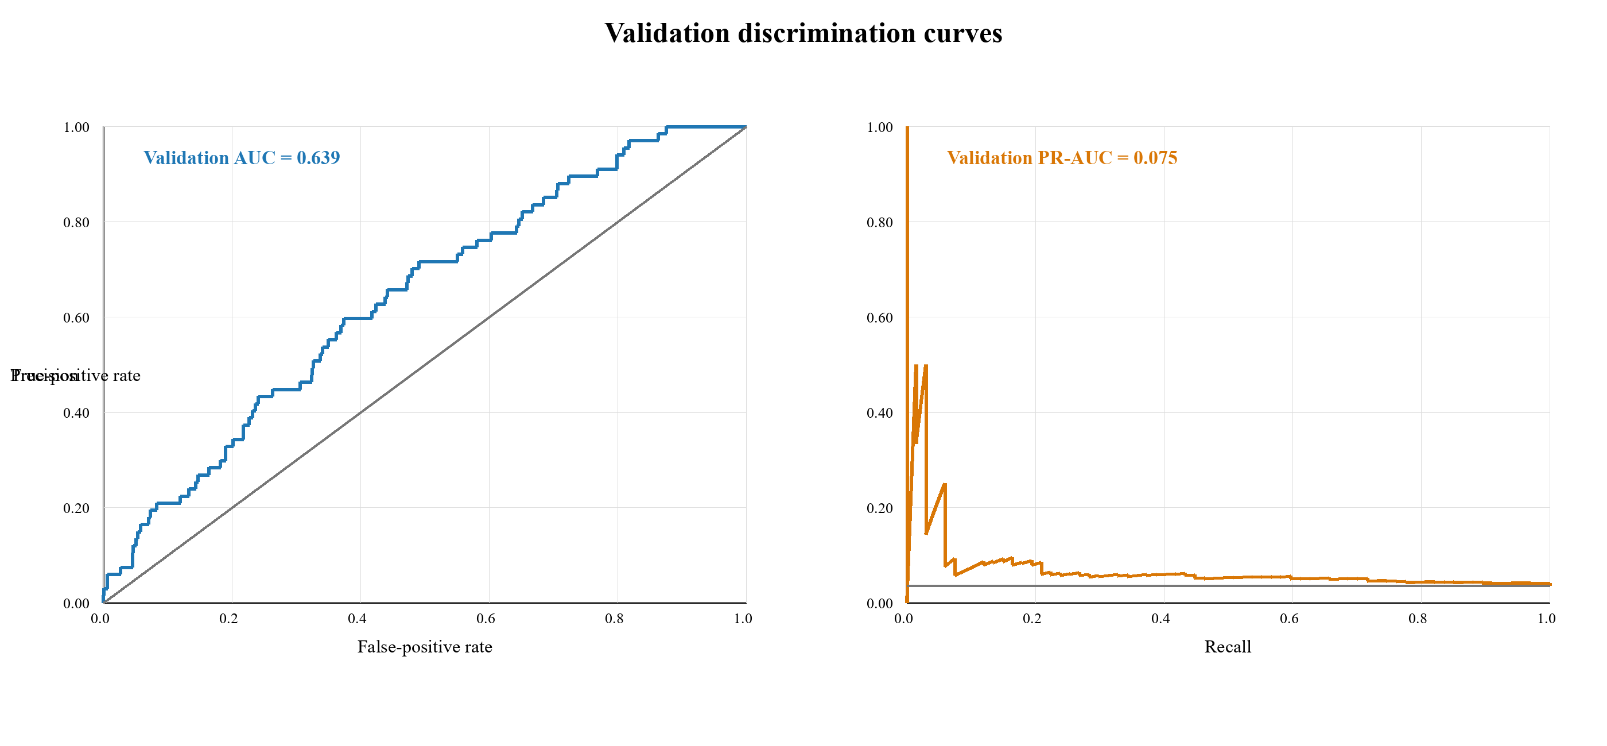
Figure 2. Validation-only ROC and precision-recall curves for the TECR-Net ensemble.
Figure 2 shows validation ROC-AUC 0.639 and PR-AUC 0.075. The ROC curve lies above the random diagonal, while the precision-recall curve remains above the 0.0356 prevalence reference over part of the recall range. The modest separation confirms useful but limited discrimination and rules out descriptions such as excellent or near-perfect performance.

4.3 Mean Validation Metrics and Learning Behaviour
Figure 3 reformats the supplied multi-split mean-metrics chart to retain only validation values, as required by the reporting scope.
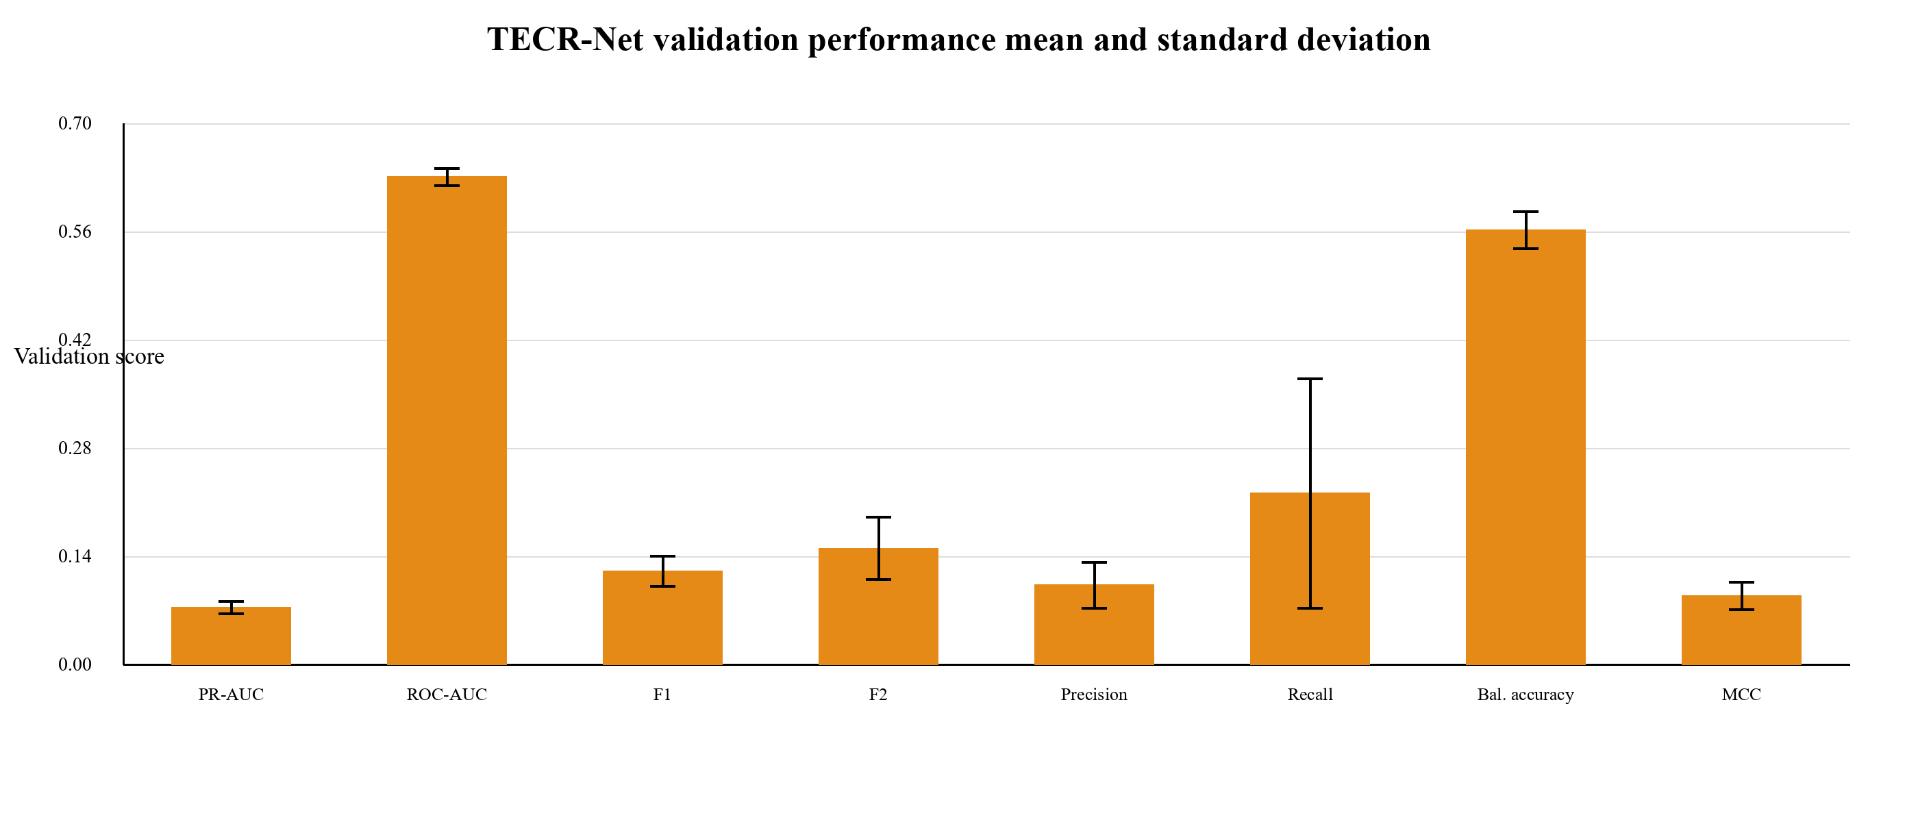Figure 3. Mean validation metrics across seven TECR-Net seeds with one-standard-deviation error bars.
Figure 3 highlights the difference between threshold-free ranking and threshold-dependent classification. ROC-AUC is the largest bounded score, whereas PR-AUC and F1 remain low in absolute terms because positives are rare and overlap substantially with negatives. The wide recall error bar shows that operating-point behaviour is sensitive to stochastic fitting, strengthening the case for ensemble probabilities and explicit uncertainty reporting.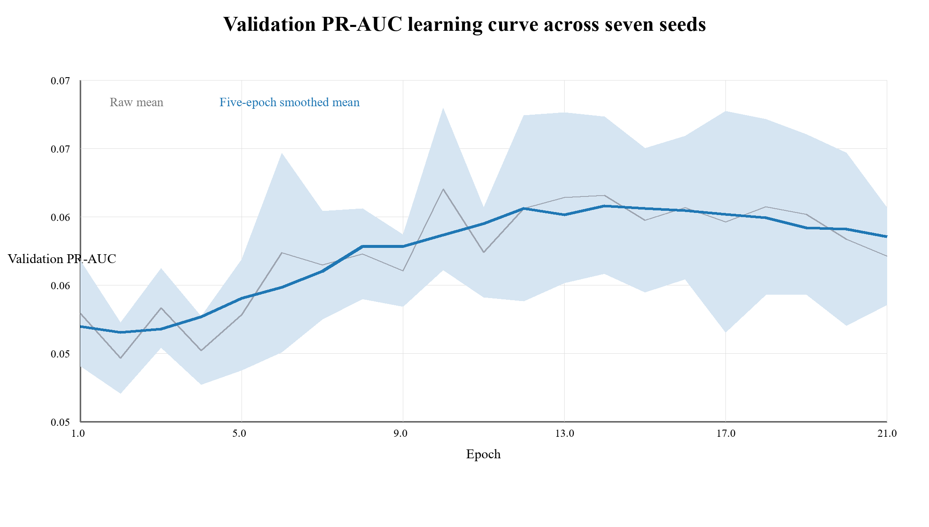Figure 4. Validation PR-AUC learning curve averaged across seven seeds and restricted to epochs completed by every seed.
Figure 4 shows an early rise in validation PR-AUC followed by a broad plateau and mild decline. The smoothed curve peaks around the middle epochs rather than at the maximum epoch limit, supporting early stopping. The widening interval also indicates increasing between-seed uncertainty, so selecting a single visually favorable epoch would overstate stability.

4.4 Sequence-Aligned Validation Baselines
Table 9. Sequence-aligned validation performance comparison of TECR-Net and four baseline models
Model | PR-AUC | ROC-AUC | F1 | Precision | Recall | Brier
TECR-Net | 0.07518 | 0.63855 | 0.12150 | 0.08844 | 0.19403 | 0.03406
CatBoost | 0.05163 | 0.62390 | 0.05405 | 0.06818 | 0.04478 | 0.07926
XGBoost | 0.05036 | 0.62903 | 0.05000 | 0.04301 | 0.05970 | 0.08115
HistGradientBoosting | 0.04891 | 0.62539 | 0.01408 | 0.01333 | 0.01493 | 0.09438
LightGBM | 0.04690 | 0.62848 | 0.04054 | 0.03704 | 0.04478 | 0.05195

Table 9 presents the validation performance of the proposed TECR-Net and four machine learning baselines, including CatBoost, XGBoost, HistGradientBoosting, and LightGBM. TECR-Net achieves the highest reported PR-AUC (0.07518), outperforming CatBoost (0.05163), XGBoost (0.05036), HistGradientBoosting (0.04891), and LightGBM (0.04690). The proposed model also records the highest ROC-AUC (0.63855), F1-score (0.12150), and recall (0.19403), indicating improved minority-class detection. Furthermore, TECR-Net achieves the lowest Brier score (0.03406), suggesting better probabilistic prediction accuracy. These results indicate promising validation performance for TECR-Net relative to the newly evaluated baselines, although its comparative advantage requires confirmation under an identical evaluation protocol and on an independent test set.
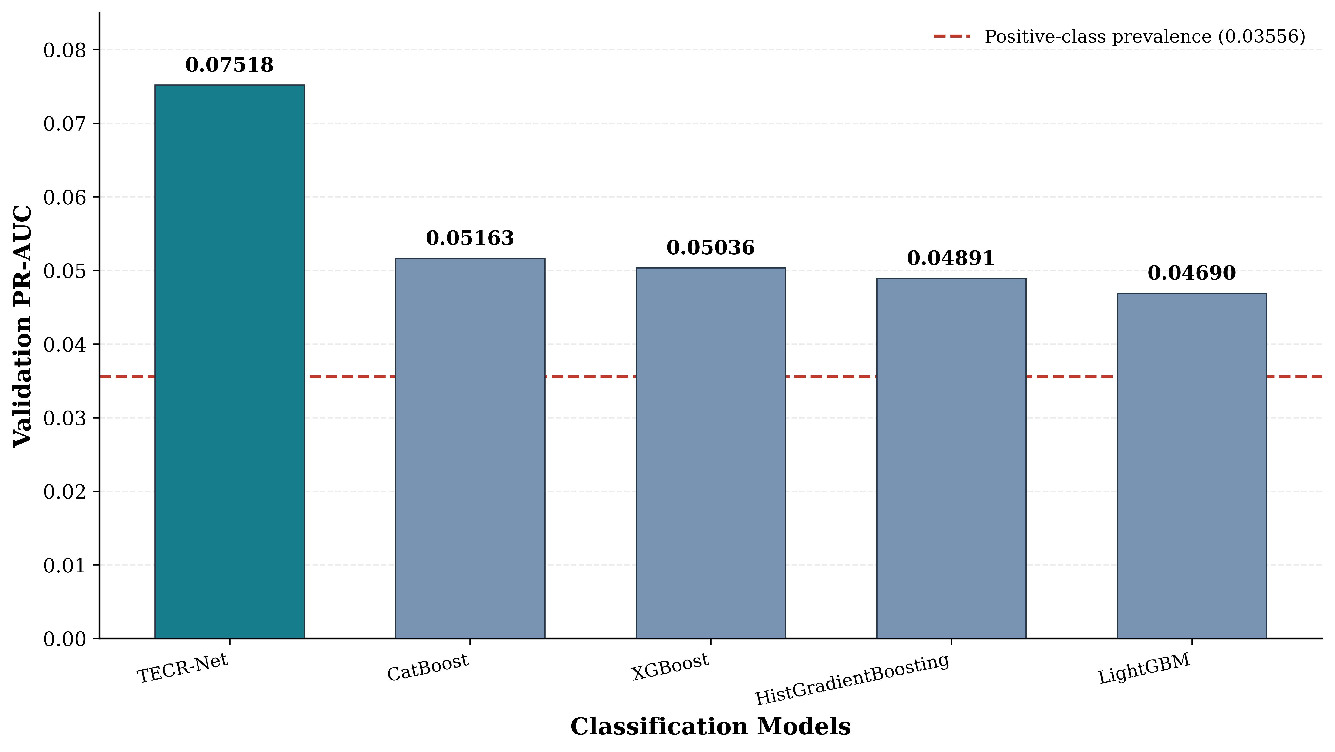
Figure 5 illustrates the reported validation PR-AUC performance of TECR-Net against four baseline models. TECR-Net achieves the highest PR-AUC of 0.07518, followed by CatBoost (0.05163), XGBoost (0.05036), HistGradientBoosting (0.04891), and LightGBM (0.04690). Relative to the strongest new baseline, CatBoost, TECR-Net achieves a 45.61% higher PR-AUC. All models exceed the positive-class prevalence baseline of approximately 0.03556, although their absolute PR-AUC values remain relatively low. The results suggest that TECR-Net offers improved positive-class ranking performance, subject to verification of identical validation sequences and experimental settings.

4.5 Architectural Ablation
Table 10 reports the full model and six prespecified removal variants using validation results only.
Table 10. Validation-only TECR-Net architectural ablation
Variant | PR-AUC | ROC-AUC
Full TECR-Net | 0.07518 | 0.63855
Without categorical encoder | 0.07374 | 0.60503
Without cross-modal attention | 0.07494 | 0.63760
Without feature gate | 0.06652 | 0.63832
Without GRU | 0.05556 | 0.63252
Without residual fusion | 0.07150 | 0.64479
Without temporal attention | 0.06938 | 0.63824

Table 10 shows that the full TECR-Net has the highest validation PR-AUC. Removing the GRU produces the largest PR-AUC reduction, from 0.07518 to 0.05556, which supports the value of ordered temporal encoding. Some variants improve individual threshold-dependent measures, such as recall or balanced accuracy, illustrating that no single operating metric captures all design trade-offs.

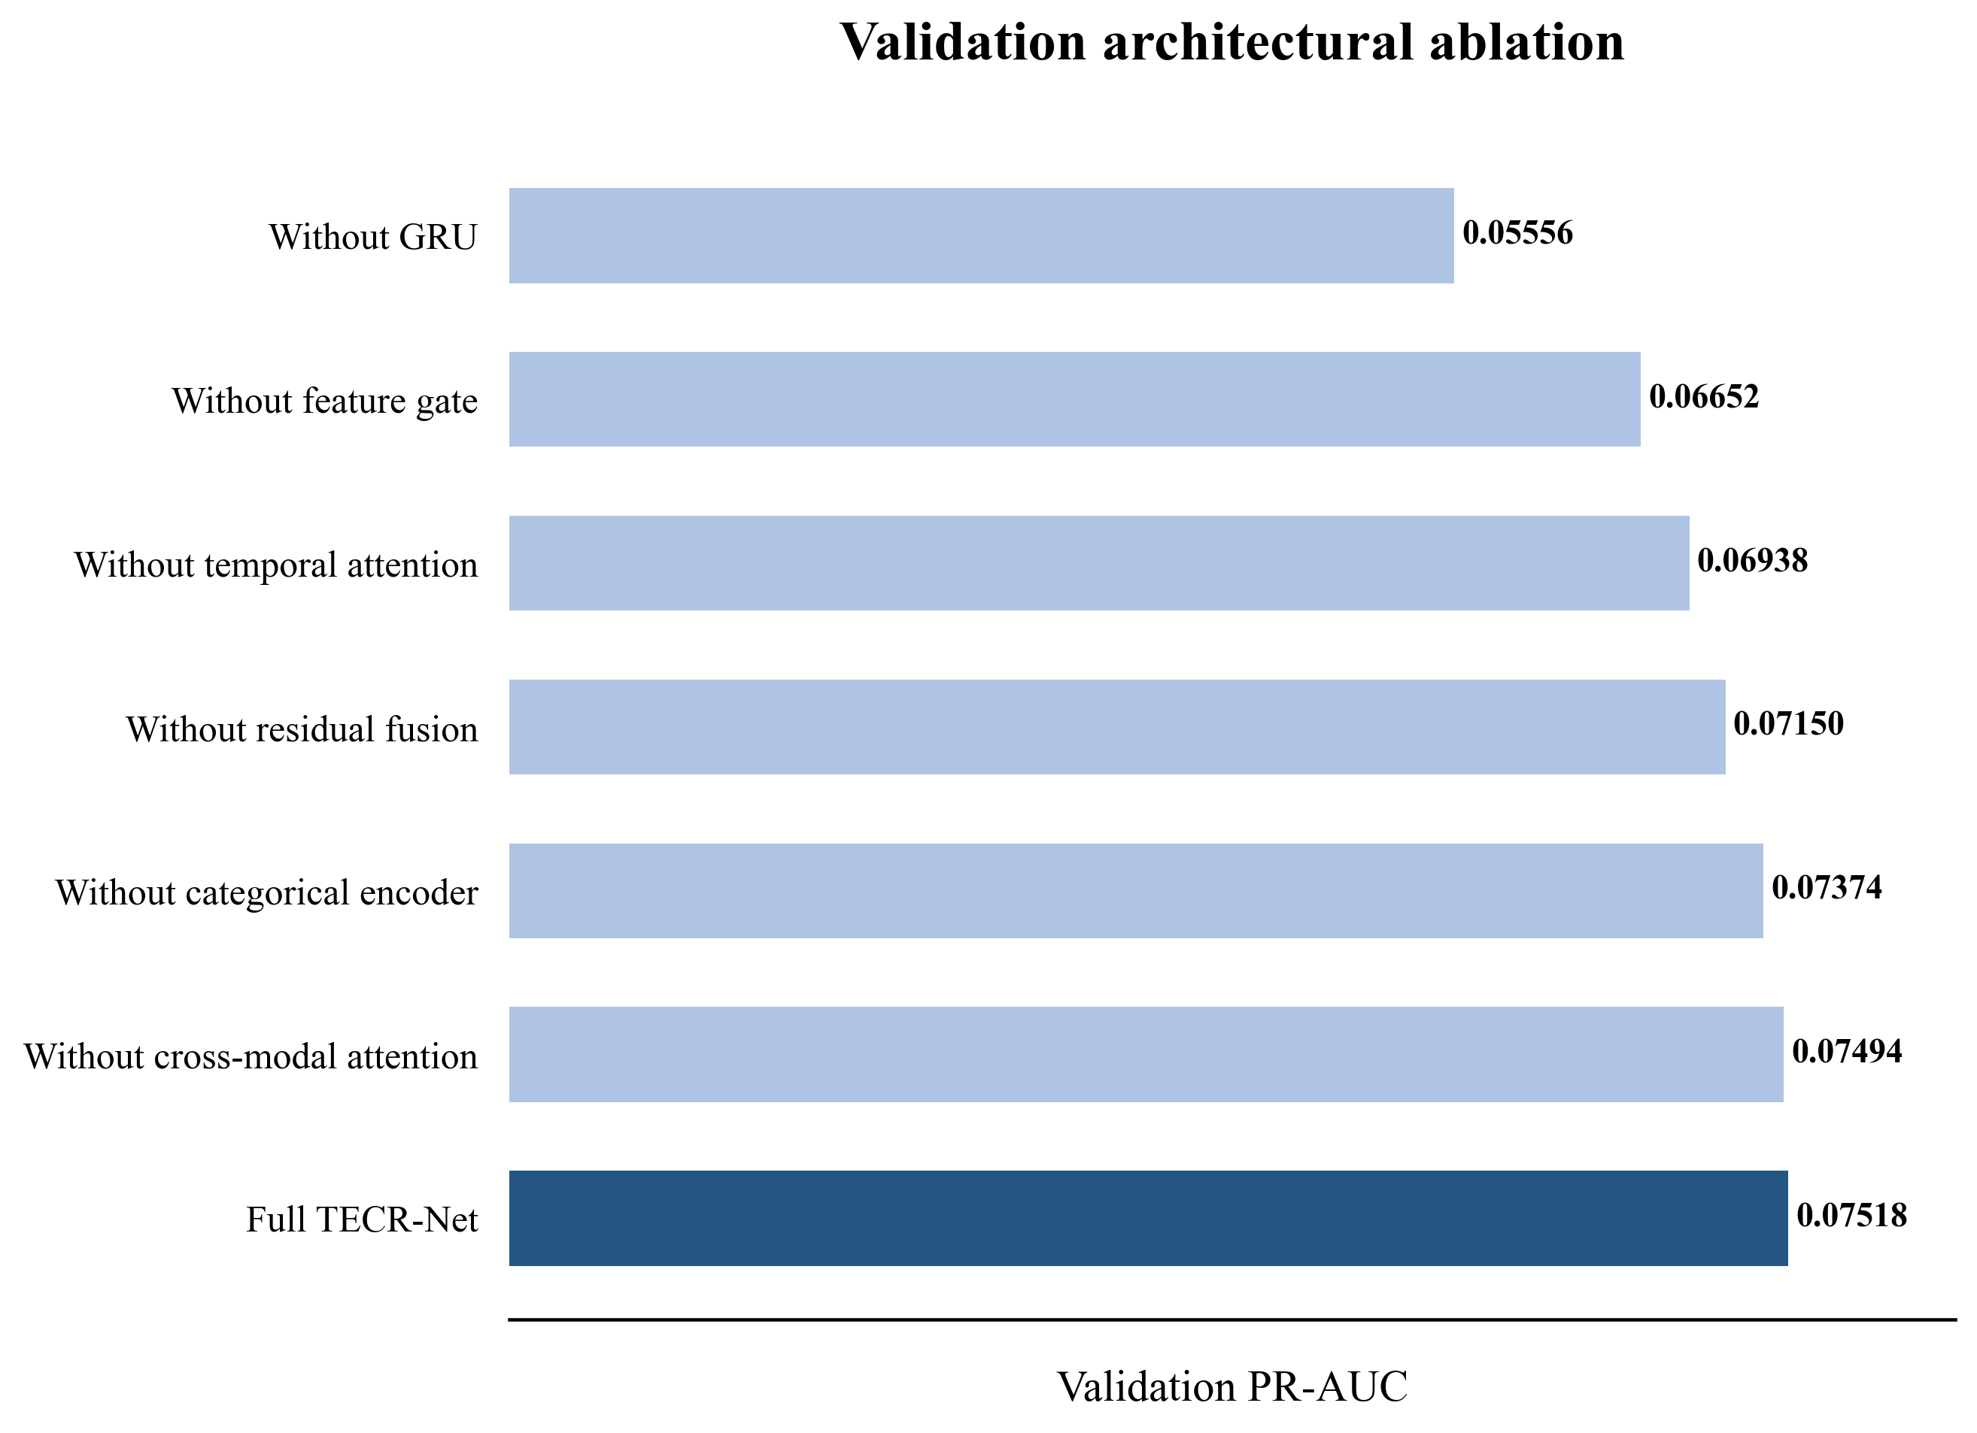
Figure 6. Validation PR-AUC for the full TECR-Net and six architectural ablations.
Figure 6 makes the recurrent encoder contribution most visible: the no-GRU variant approaches the prevalence baseline more closely than the other variants. The small difference between the full model and removal of cross-modal attention indicates that this module contributes less validation PR-AUC than the recurrent pathway, even though it may affect threshold-dependent behaviour.

4.6 Accident-Feature Sensitivity
Table 11 evaluates whether the primary validation result depends on the three coarse lease-level accident proxies.
Table 11. Validation sensitivity to lease-level accident proxies
Variant | PR-AUC | ROC-AUC | F1 | Precision
Full TECR-Net | 0.07518 | 0.63855 | 0.12150 | 0.08844
Without lease-level accident proxies | 0.07478 | 0.62849 | 0.12091 | 0.07273

Table 11 shows nearly unchanged validation PR-AUC after removing the accident proxies (0.07518 versus 0.07478). The reduced model increases recall and precision@50 but lowers ROC-AUC slightly. The primary ranking conclusion is therefore not materially dependent on these duplicated lease-level variables, although threshold-dependent operating behaviour changes.

4.7 Validation Uncertainty and Calibration
Table 12 reports uncertainty and calibration diagnostics calculated exclusively from the validation ensemble predictions.
Table 12. Validation bootstrap intervals and calibration diagnostics
Diagnostic | Estimate | 95% bootstrap CI / basis | Interpretation
PR-AUC | 0.07518 | 0.04457–0.13278 | Primary rare-event ranking
ROC-AUC | 0.63855 | 0.57499–0.70282 | Moderate discrimination
Brier score | 0.03406 | 0.02632–0.04188 | Probability error
Expected calibration error | 0.00000 | Descriptive | Weighted bin-wise gap
Maximum calibration error | 0.00000 | Descriptive | Largest occupied-bin gap
Validation prevalence | 0.03556 | 67 / 1,884 | Rare outcome

Table 12 shows wide uncertainty around discrimination because only 67 validation positives are available. The Brier score is numerically low, but this partly reflects the low event rate. Moreover, Platt calibration was fitted on the same validation cohort, so the calibration errors are apparent rather than independently verified. External recalibration remains mandatory before us
5. Discussion
TECR-Net demonstrated modest but meaningful risk-ranking ability, achieving a validation PR-AUC of 0.07518—approximately 2.11 times the outcome prevalence—and a ROC-AUC of 0.63855. However, the confusion matrix identified only 13 of 67 positive cases at the selected threshold. Precision@50 was 0.08, corresponding to approximately four INC-positive platforms among the 50 highest-ranked facilities. Therefore, TECR-Net should be interpreted as an inspection-prioritization tool rather than an autonomous screening or enforcement system.The ablation analysis supports the importance of temporal modelling. Removing the GRU caused the largest PR-AUC reduction, whereas removing cross-modal attention produced only a marginal decline. This indicates that ordered historical information contributes more strongly than individual fusion components. Nevertheless, attention and feature-gating weights represent model associations and should not be interpreted as causal risk factors.
Among the aligned baselines. TECR-Net’s contribution instead lies in its explicit temporal structure, multimodal feature integration and transparent ablation design. Because model selection, threshold determination and calibration involved the validation period, the reported performance remains internally estimated. Independent prospective evaluation, separate probability recalibration and inspection-capacity-based threshold selection are required before operational deployment.

6. Limitations

The reported results are based on internal validation. Model selection, threshold optimization and calibration involving the same period may produce optimistic performance estimates; an untouched external or prospective cohort is required.

The target represents a recorded INC rather than latent non-compliance. Its occurrence depends on inspection frequency, reporting practices and regulatory activity, while complete facility-level records of inspections without INCs were unavailable.

Inclusion requires an observable next-year platform record, potentially excluding facilities that cease production or disappear. Lease-level accident variables may also be repeated across multiple platforms, limiting platform-specific attribution.

The validation cohort contained only 67 positive cases, resulting in uncertain and seed-sensitive estimates. Furthermore, the model was developed using U.S. offshore BSEE data, and its transferability to other jurisdictions, asset classes and enforcement systems remains unverified.

7. Conclusion

TECR-Net provides a coherent temporal cross-modal framework for next-year recorded INC prioritization in offshore platforms. On internal validation, the seven-seed ensemble achieved PR-AUC 0.0752, 2.11-fold lift over prevalence, ROC-AUC 0.6386, F1 0.1215, and Brier score 0.0341. The recurrent temporal encoder made the clearest contribution in ablation, and removal of coarse accident proxies had little effect on primary validation PR-AUC.. The accurate scientific conclusion is therefore not that TECR-Net is decisively superior, but that it is a promising structured model requiring independent prospective confirmation. Until such evidence is available, TECR-Net should be presented as a research prototype for ranking and inspection-planning analysis rather than a deployable regulatory decision system.

References
[1] Liu, B., Li, Z., Duan, Q., Yan, B. and Tan, X., 2025. Research on LLM-based assessment methods for international standards' intelligent contribution to oil and gas pipelines. Journal of Pipeline Science and Engineering, p.100405.
[2] Hui, Q., Liu, B., Fan, J., Guo, D., Chen, J., Tan, X. and Peng, Z., 2026. Knowledge graph construction for pipeline standards: Enhancing efficiency in the oil and gas industry. Journal of Pipeline Science and Engineering, p.100445.
[3] Xia, T., Wang, F., Huang, Z., Zhang, W., Chen, G., Zhou, J. and Liu, C., 2025. Multi-Dimensional Control Rules and Assessment Methods for Surface Engineering Data Quality in Oil and Gas Field. Information, 16(8), p.701.
[4] Khordoustan, P., Akbarzadeh, O., Gilani, N., Moshashaei, P. and Alizadeh, S.S., 2026. A hybrid ANP and machine learning framework for contractor health safety environment and quality performance evaluation. Discover Analytics, 4(1), p.16.
[5] Wahono, T., Purniawan, A., Mukhlash, I. and Putri, E.R., 2025. Risk-based asset integrity management in the oil and gas industry from traditional to machine learning approaches: A systematic review. Results in Engineering, p.107287.
[6] Zhang, X., Yan, L., Lai, F. and Wang, H., 2025. Research progress and prospects of risk assessment methods for oil and gas development. Geoenergy Science and Engineering, 253, p.213992.
[7] Wahono, T., Mukhlash, I., Putri, E.R. and Purniawan, A., 2026. An intuitionistic fuzzy deep neural network method for risk assessment of oil and gas pipelines. Cleaner Engineering and Technology, p.101299.
[8] Zhou, Y., Fan, J., Dai, B. and Wu, S., 2025. A data-driven PCA-hierarchical clustering framework for adaptive risk assessment of gas pipeline networks. Process Safety and Environmental Protection, p.107753.
[9] Ye, Z., Duan, Q. and Ma, S., 2026. Research on risk classification of oil and natural gas pipelines based on text mining and apriori algorithm. Journal of Loss Prevention in the Process Industries, 103, p.106059.
[10] AlAbdouli, M.A. and Al-Shihabi, S., 2025. Artificial intelligence and its performance impacts in the oil and gas industry: Challenges, insights, and evaluation approaches. Results in Engineering, p.107636.
[11] Savari, A., Li, Y., Alnefaie, K. and Singh, N.S.S., 2026. State-of-the-art Machine learning Advances in reliability-based design, integrity assessment, inspection and maintenance of pipelines: A Systematic review. Journal of Pipeline Science and Engineering, p.100528.
[12] Bastek, T., Denecke, J. and Schmidt, J., 2026. Future directions for data-driven approaches in pipeline integrity management: Risk assessment, in-line inspection, and machine learning. Reliability Engineering & System Safety, p.112300.
[13] Jones, J.F., Raj, V., Abas, P.E., Petra, M.I., Sivan, D., Satheesh Kumar, K., Jose, R. and Mathew, S., 2025. Application of artificial intelligence for asset integrity management of offshore oil and gas pipelines. Life Cycle Reliability and Safety Engineering, 14(4), pp.503-530.
[14] Al-Ammari, W.A., Sleiti, A.K., Rahman, M.A., Rezaei-Gomari, S., Hassan, I. and Hassan, R., 2025. Digital twin for leak detection and fault diagnostics in gas pipelines: A systematic review, model development, and case study. Alexandria Engineering Journal, 123, pp.91-111.
[15] Cai, X. and Wang, J., 2026. A digital twin-driven natural gas pipeline leakage detection method. International Journal of Pressure Vessels and Piping, p.105793.
[16] Ali, U., Naveen, P., Al-Shalabi, E.W. and Ait Abderrahmane, H., 2026. Artificial intelligence and machine learning for production prediction and optimization of oil and gas surface networks. Energy and AI, p.100772.
[17] Chen, Y., Chen, P., Wang, Y., Feng, G., Yang, C. and Wang, Q., 2025. From clustering to federated learning: A collaborative approach to optimizing data-driven models for the production monitoring of unconventional natural gas wells. Gas Science and Engineering, 137, p.205580.
[18] Lopes, L.G.O., de Almeida Vieira, T.M., Aranha, P.E., de Lima Junior, E.T. and Lira, W.W.M., 2025. Detection and classification of anomalies in oil well production using Open-World Learning. Engineering Applications of Artificial Intelligence, 159, p.111514.
[19] Aranha, E.P., Policarpo, A.N. and Sampaio, A.M., 2025. A Transformer-based approach for anomaly detection in intelligent well completions. Petroleum Exploration and Development, 52(4), pp.1029-1040.
[20] Verma, P., Gandhi, K., Cheema, A.M., Ashfaq, M., Shah, D., Ali, S. and Tahir, M., 2026. DeepPipeNet enables deep learning based anomaly detection for oil and gas pipeline monitoring. Discover Applied Sciences, 8(5), p.498.
[21] Almahakeri, M., Al-Mahasneh, A.J., Mallouh, M.A. and Jouda, B., 2025. Deep neural network-based intelligent health monitoring system for oil and gas pipelines. Applied Soft Computing, 171, p.112827.
[22] Wang, M., Su, X., Song, H., Wang, Y. and Yang, X., 2025. Enhancing predictive maintenance strategies for oil and gas equipment through ensemble learning modeling. Journal of Petroleum Exploration and Production Technology, 15(3), p.46.
[23] Sani, A.A., Wahab, M.M.A., Shafiq, N., Danyaro, K.U. and Aliyu, Y., 2026. Data-Driven Ensemble Machine Learning for Corrosion Risk Prediction and Maintenance Optimization in Oil and Gas Pipelines. Results in Engineering, p.110288.
[24] Ansari, E., Izadkhah, M., Mohimi, A., Akhtar, M.N. and Bakar, E.A., 2026. Prediction of Internal Corrosion in Oil and Gas Piping Systems—An Independent Analysis Using Machine Learning. Journal of Pipeline Science and Engineering, p.100522.
[25] Wu, T., Miao, X. and Song, F., 2025. Residual strength prediction of corroded pipelines based on physics-informed machine learning and domain generalization. npj Materials Degradation, 9(1), p.12.
[26] Wang, Q. and Lu, H., 2025. Machine learning methods for predicting residual strength in corroded oil and gas steel pipes. npj Materials Degradation, 9(1), p.30.
[27] Chen, X., Huang, S., Guan, T. and Fu, H., 2025. An interpretable predictive model for liquid holdup of hilly terrain oil-gas pipelines based on machine learning and Shapley additive explanations. ACS omega, 10(15), p.15160.
[28] Lv, X., Yin, Z., Chen, S., Liu, Y., Yao, H., Ma, Y., Wang, C., Ma, Q., Li, X. and Zhou, S., 2026. Risk assessment model for hydrate blockage in deep-sea oil and gas multiphase pipelines based on XGBoost and SHAP. Chemical Engineering Science, p.124205.
[29] Yang, Y., Wang, B., Cen, X., Shao, B., Zhu, B., Yang, J. and Hong, B., 2025. Susceptibility risk assessment of oil and gas pipeline geological hazards in mountainous areas based on data-driven model. Engineering Applications of Artificial Intelligence, 151, p.110732.
[30] Chen, S., Zhang, N., Shui, B., Zhang, T., Li, C. and Gong, Q., 2025. Real‐Time Prediction of Overpressure‐Induced Pipeline Failure via Edge‐Optimized Machine Learning. Energy Science & Engineering, 13(10), pp.4730-4744.
[31] Khalilzadeh, M., Banihashemi, S.A., Heidari, A., Orazani, S.M.H. and Taebi, P., 2025. Risk management in the production phase of oil and gas projects: evaluating risk responses and their impact on safety and damage reduction. Discover Civil Engineering, 2(1), p.91.
[32] Zhang, F., Feng, Y. and Li, X., 2025. Application of big data and artificial intelligence in oilfield production optimization and intelligent management: A systematic analysis of real-time monitoring and parameter optimization. Advances in Resources Research, 5(1), pp.16-30.

